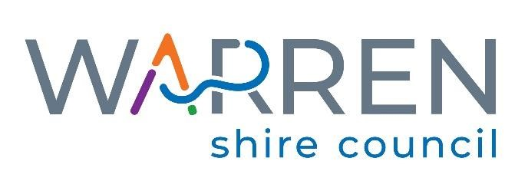

General Information for the Position
of
Water & Sewer Team Leader /Plumber

Applications will close when the right applicant is found

Further Information can be obtained from:

Human Resources - (02) 6847 6600

115 Dubbo Street,
(P.O. Box 6) Phone: (02) 6847 6600
WARREN NSW 2824

SCHEDULE 1

ADVERTISEMENT FOR THE POSITION

Water & Sewer Team Leader /Plumber

POSITION VACANT
Water and Sewer Team Leader / Plumber
Position Details
Salary: Administrative/Technical/Trades Band 2, Level 2. - $1,187.70 to $1,377.73
Full Job Description: Available on Councils website www.warren.nsw.gov.au
Employment Type: Permanent Full Time
The Opportunity
Working in the Engineering Services Department, the Water & Sewer Team Leader/Plumber will undertake a reactive and proactive maintenance program for the water, sewer and stormwater pumping, storage and reticulation systems across Council owned assets.

About You
To be successful in this role you will have a current Class MR Drivers Licence, Certificate III in Plumbing (CPC32413/ CPC32412/ CPC32411/ CPC32408/ BCP30103), White Card and Tradesperson Certificate or a combination of base level qualifications, workplace learning or you will possess demonstrated industry knowledge and experience.
In addition to the above, you will possess high level communication and people skills and have an ability to manage conflicting demands and execute projects within appropriate timeframes.
Benefits
This is a permanent full-time role with a salary range based on demonstrated competencies and experience + 10% p.a. superannuation.
Council also offers a range of other benefits for its employees, including:
Flexi days
Ongoing training and development
Long service leave after 5 years
Questions?
Should you have any further questions, please contact Raymond Burns, Acting Divisional Manager Engineering Services, on 02 6847 6600.

Applications
Applications will close when the right applicant is found.
An information package must be obtained by attending the Administration Centre, 115 Dubbo Street, Warren or by visiting Council website www.warren.nsw.gov.au
Applications can be lodged:
- Via mail – P.O. Box 6, Warren, NSW, 2824
- In person – 115 Dubbo Street, Warren, NSW, 2824
- Via email – hr@warren.nsw.gov.au

Warren Shire Council recognises the skills and attributes of Veterans and welcomes applications from ex-service personnel.
Council is an Equal Employment Opportunity employer.

SCHEDULE 2

POSITION DESCRIPTION

Water & Sewer Team Leader /Plumber

Position Description

Position Title: Water and Sewer Team Leader / Plumber

Department: Engineering - Town Services

Classification: Administrative/Technical/Trades Band 2, Level 2. $1,187.70 to $1,377.73 increasing to $1,211.45 to $1,405.28 in July 2022.

Allowances: Adverse Working Conditions and Sewer Choke (maximum one paid per day)
Grading: Local Government (State) Award 2017 Progression between Grades 1-5 is in line with Council’s Salary System.
Hours of Duty: 9 day (76 hour) fortnight
Summer- 6.15am to 3.30pm, 30 minute lunch break
Winter- 7.00am to 4.15pm, 30 minute lunch break
Annual Leave: 4 weeks per year
Responsible Officer: Town Services Manager
Immediate Supervisor: Town Services Overseer

Position Objectives:

To manage the staff in your area of responsibility in an efficient and effective manner;

be available for after-hours emergencies and participate in the operational and on-call roster;

To provide input into management decisions to improve the effectiveness of the organisation;

To liaise with the Services Overseer and Town Services Manager on a regular basis to discuss current and any foreseeable issues affecting the section;

To actively promote WH&S in the work environment, in particular the water and sewer area; and

To participate in and manage workplace change in the water and sewer area.

Licences, Qualifications and Experience:

Essential:

- Licenced Plumber;
- General Construction Induction Card (White Card);
- Class MR Manual Driver’s Licence;
- Experienced and competent in the construction and maintenance of water mains and services, sewer mains and manholes, storm water pipe work and pits and all associated valves;
- Mechanical knowledge of pumps, valves and small plant;
- Good computer knowledge/skills with a working knowledge of Word and Excel; and
- Manual Handling Training.

Desirable:
- Backflow Prevention Certificate;
- First Aid Certificate;
- Certificate of Competency as a Backhoe Operator;
- Certificate of Competency as a Mini Excavator Operator;
- Chainsaw Certificate Level 1;
- Chemical Handling and Awareness Training;
- Chlorine Gas Safety Training;
- Confined Space Entry Training;
- Breathing Apparatus Training;
- Supervise Asbestos Removal Certification; and
- Work Safely at Heights Training.

Schedule of Duties:
- Advise the Town Services Manager/ Services Overseer on action necessary towards ineffective or undisciplined members of staff;
- Complete all works on time and within budget;
- Complete any sundry debtor works, ensuring all paperwork is completed as per Council Procedure as required;
- Complete other duties as required by the Town Services Manager or any other authorised Supervisor;
- Ensure that the W&S staff abide by the requirements set out in Warren Shire Council Code of Conduct;
- Ensure that the W&S staff dress in a clean and presentable manner at all times;
- Ensure that W&S staff complete time sheets/plant sheets in a timely manner and that these sheets are then forwarded to the Services Overseer within the required timeframe;
- Liaise and consult with appropriate supervisors/ managers to coordinate resources for the completion of works or as necessary for assistance;
- Management of day to day operation and maintenance of the water and sewer section;
- Promote with the W&S staff and sense of pride in their work and their section;
- Report any accidents/incidents to the appropriate supervisor as soon as possible;
- Report any plant issues or defects to the Services Overseer for attention;
- Resolving minor disputes that may arise in the water and sewer section; and
- Works within the level of responsibility allocated to the position.

Customer Service
- Attend to enquiries from internal and external customers promptly and professionally;
- Communicate effectively and sensitively with both internal and external customers;
- Objectively solve disputes and/or problems that may arise with internal and external customers;
- Project and promote the image of Council as both positive and efficient through maintaining professional standards and presentation; and
- Work cooperatively with other sections of Council and organisations.

Work Health and Safety Responsibilities
All employees are responsible for WHS at Council and their duties include:
- Completing Safe Work Method Statements and Risk Assessments for all jobs prior to starting each job;
- Complying with any Return to Work Plan if injured;
- Complying with Emergency and Evacuation procedures;
- Correctly using all Personal Protective Equipment;
- Participate in WHS consultation arrangements in your workplace;
- Providing suggestion, through agreed consultation method, on how to improve WHS issues;
- Reporting all injuries and illnesses to their supervisor and the Work Health Safety/Risk Officer within 24 hours of the incident;
- Reporting all WHS hazards and incidents to their supervisor with the associated Incident Report;
- Reporting any faulty equipment or plant to the Services Overseer;
- Seek assistance if unsure of WHS procedures; and
- Working in a safe manner without risk to themselves, others, Council’s equipment or the environment.

Physical Demands
The position holder is required to be physically fit as they are likely to be exposed to a range of outdoor activities and also prolonged sitting, close eye work; trench work; dealing with the public; meeting deadlines. Planned and unplanned work outside of normal work hours as occurs.

Key Accountabilities
- Adherence to adopted safe working practices;
- Adherence to adopted works specifications;
- Adherence to all adopted policies of Council;
- Adherence to authorised working hours;
- Advise Services Overseer if unable to attend or complete work or training;
- Carry out duties as instructed and as required;
- Control of plant and materials under the direct control of the Water and Sewer Team Leader;
- Demonstration of good driving/operating and low maintenance record for plant operated;
- Ensure all records are maintained;
- Ensure harmonious and productive relationships exist with Council Staff;
- Promote a positive image of Council.

Output Measures

- Attendance record
- Number of work safety incidents
- Presentation
- Record of staff matters
- Standard of workmanship

Position Skill Descriptors:
Authority and Accountability:
Responsibility as a trainer/co-ordinator for the operation of a small section which uses staff and other resources, or the position completes tasks requiring specialised technical/administrative skills.

Judgement and problem solving:
Skills to solve problems which require assessment of options with freedom within procedural limits in changing the way work is done or in the delegation of work. Assistance may be readily available from others in solving problems.

Specialist knowledge and skills:
Positions will have specialised knowledge in a number of advanced skill areas relating to the more complex elements of the job.

Management skills:
May require skills in supervising a team of staff, to motivate and monitor performance against work outcomes.

Interpersonal skills:
In addition to interpersonal skills in managing others, the position may involve explaining issues/policy to the public or others and reconcile different points of view.

Qualifications and experience:
Thorough working knowledge and experience of all work procedures for the application of technical/trades or administrative skills, based upon suitable certificate or post-certificate-level qualifications.

Warren Shire Council
Competencies and Skills

Job Title: Water & Sewer Team Leader
Band: 2
Level: 2

 | Skills Obtained
Grade 1 | Yes | No
Ability to communicate with the public
Basic plant maintenance
Basic record keeping
MR Licence
Construction Induction White Card
Knowledge of Anti-discrimination Act
Proof that Introduction to New Staff has been read
Safe Operation of light equipment
Safe Operation of light plant (no Workcover Ticket required)
Traffic Control- Stop/Slow
Understanding of WH & S
Grade 2
Ability to load correctly, stably and securely
Backhoe Competency Ticket
Basic knowledge of landscaping
Chemical application Certificate
Chlorination Certificate
Confined Spaces
Demonstrate ability to co-operate and work as a team
Demonstrate ability to work unsupervised
Demonstrated ability to effectively lead, motivate, support and develop a team, ensuing they achieve work targets and objectives safely and efficiently
Forklift High Risk Work Licence
HR Licence or higher
Licenced Plumber with Backflow Prevention Certification
Traffic Control- Implement Traffic Control
Understanding of pump operation & maintenance
Understanding of Warren Shire Sewerage System
Understanding of Warren Shire Water Supply

Warren Shire Council
Competencies and Skills

Job Title: Water & Sewer Team Leader
Band: 2
Level: 2

 | Skills Obtained
Grade 3 | Yes | No
Certificate III Water Industry Course or 3 years industry experience
First Aid Certificate
Knowledge of stores issue & ordering procedures
Sound working knowledge of WH&S e.g., SWMS and MSDS
Well-developed time management, organisational and problem solving skills with an ability to meet deadlines
Working knowledge of pump operation and maintenance
Working knowledge of Warren Shire Water & Sewerage Supply
Grade 4
Ability to calculate and measure quantities of materials
Sound knowledge of pump operation and maintenance
Sound knowledge of Warren Shire Water & Sewerage Supply
Sound working knowledge of Warren Shire Sewerage System
Grade 5
Certificate IV Water Operations
Demonstrated ability to competently act in the Services Overseer Position
Local Government Operations Certificate 2 (or 5 years relevant industry experience)
Mechanical aptitude in competency to weld

SCHEDULE 3

Employment Application Form

Water & Sewer Team Leader/Plumber

Privacy Statement:
As part of the recruitment process Warren Shire Council will be collecting information about you. This information is private information for the Privacy and Personal Information Protection Act. This information will be included in the recruitment file and accessed by Council Human Resources staff and members of the Recruitment Selection Panel. Applicants may request their information be returned to them at the conclusion of the recruitment process.

Personal Details * Required Fields
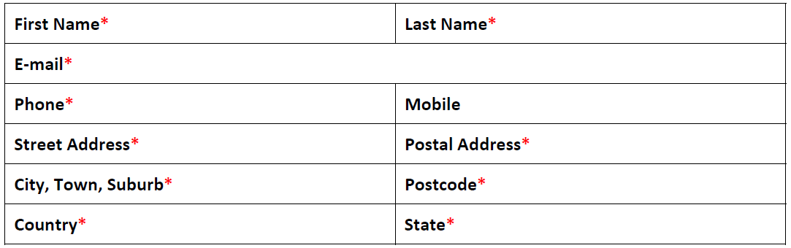
Questions
1. Please indicate your eligibility to work in Australia*
a. Australian/New Zealand Citizen
b. Permanent Resident
c. Current Visa including Visa Class and duration (expiry date)
d. None of the above
2. If you answered Current Visa or None of the above, please provide details of your eligibility to work in Australia including Visa date or issue and any Visa restrictions

3. Have you read and understood the position description and the requirements for the
position that you are applying for? *
a. Yes
b. No
4. Have you ever previously been employed by Warren Shire Council? *
a. Yes
b. No
5. Have you ever been a serving full-time member of the Australian Defence Force, or a reservist on continuous full-time service?
a. Yes
b. No
6. Do you identify as an Aboriginal or Torres Strait Islander?
a. Yes
b. No

